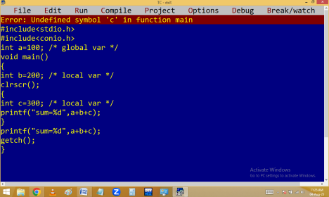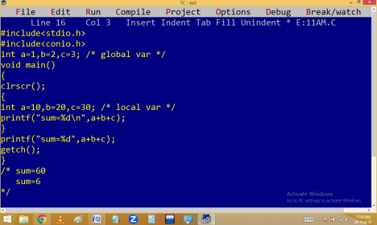
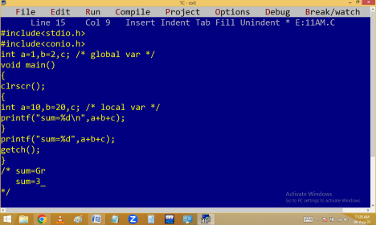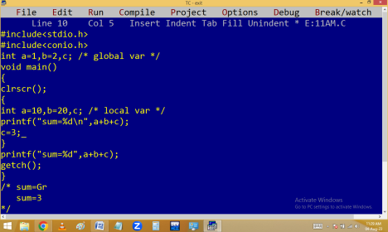
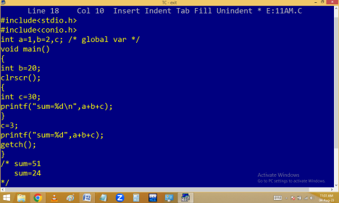
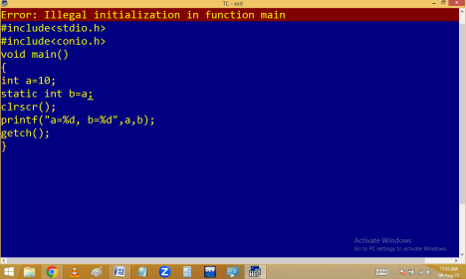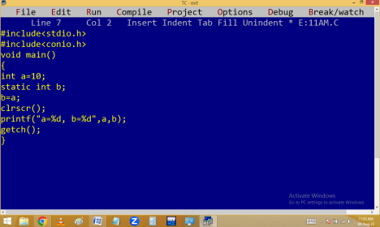
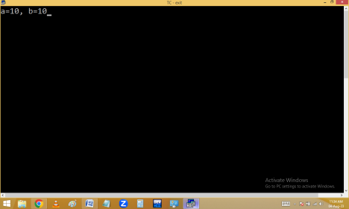
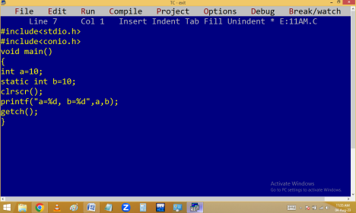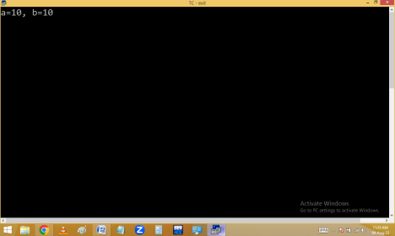
scanf(): It is the major input function in C.
it is used to read the values at runtime from the user. Scanf always refers standard input device i.e. keyboard.
In scanf, f means formatted.
it belongs to <stdio.h>
Syntax:
int scanf( “conversion characters”, &var, &var,…..); ∙ Here scanf() returns an integer which indicates the no of conversion characters we have used in scanf(). ∙ Generally conversion characters are the first arguments and they should be placed in “ “.
∙ Space is optional in between the conversion characters. When comma / any character is entered in between conversion characters, at run time also
we have to enter the same letter in between the values.
∙ & indicates address of variable. & is mandatory for all data types except string type variables.
Eg: Write a C program to find the no of conversion characters in scanf().
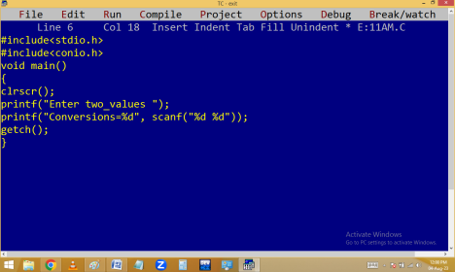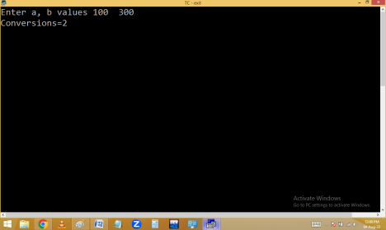
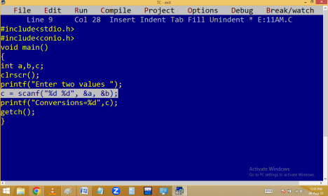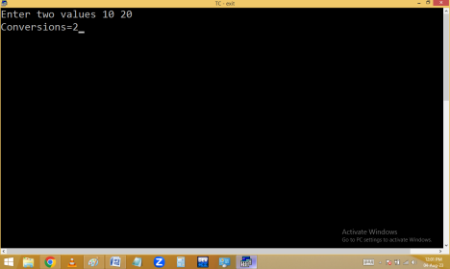
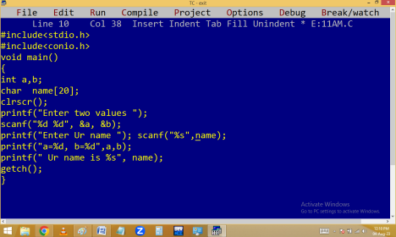
Controlling inputs in scanf():
Eg. Finding simple interest and net.
Finding area and circumference of a circle.
Celsius to Fahrenheit conversion:
F=C*1.8+32
Fahrenheit to Celsius:
C = (f-32)*(5/9)

